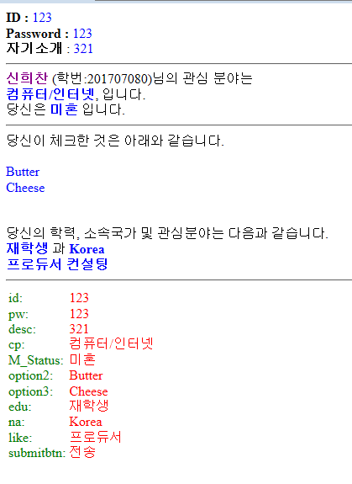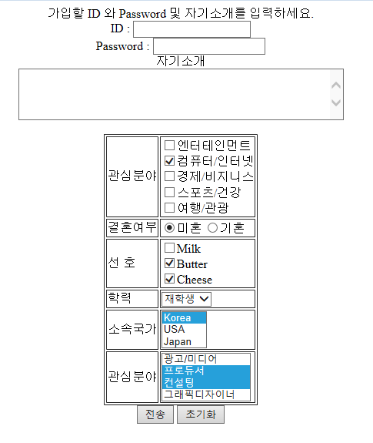

**Pro.jsp**

<%@ page language=*"java"*

contentType = *"text/html; charset=UTF-8"*

pageEncoding=*"UTF-8"* %>

<!DOCTYPE html>

<html>

<head>

<meta charset=*"UTF-8"*>

<title> Insert title here </title>

</head>

<body>

<center> 가입할 ID 와 Password 및 자기소개를 입력하세요.</center>

<form action=*"rcform.jsp"* method=*"post"* name=*"textform"*>

<center>

ID : <input type=*"text"* name=*"id"*><br/>

Password : <input type=*"password"* name=*"pw"*> <br/>

자기소개<br/>

<textarea name=*"desc"* cols=*"50"* rows=*"4"*></textarea><br><br>

<div style="text-align:*center*;">

<table border=*"1"* style="margin-left: *auto*; margin-right: *auto*;">

<tr>

<td align=*"left"*> 관심분야 </td>

<td align=*"left"*>

<input type=*"checkbox"* name=*"cp"* value=*"엔터테인먼트"*>엔터테인먼트<br/>

<input type=*"checkbox"* name=*"cp"* value=*"컴퓨터/인터넷"* checked>컴퓨터/인터넷<br/>

<input type=*"checkbox"* name=*"cp"* value=*"경제/비지니스"*>경제/비지니스<br/>

<input type=*"checkbox"* name=*"cp"* value=*"스포츠/건강"*>스포츠/건강<br/>

<input type=*"checkbox"* name=*"cp"* value=*"여행/관광"*>여행/관광<br/>

</td>

</tr>

<tr>

<td align=*"left"*>결혼여부</td>

<td align=*"left"*>

<input type=*"radio"* name=*"M_Status"* value=*"미혼"* checked>미혼

<input type=*"radio"* name=*"M_Status"* value=*"기혼"*>기혼<br/>

</td>

</tr>

<tr>

<td align=*"left"*>선 호</td>

<td align=*"left"*>

<input type=*"checkbox"* name=*"option1"* value=*"Milk"*>Milk<br/>

<input type=*"checkbox"* name=*"option2"* value=*"Butter"* checked>Butter<br/>

<input type=*"checkbox"* name=*"option3"* value=*"Cheese"* checked>Cheese<br/>

</td>

</tr>

<tr>

<td align=*"left"*>학력 </td>

<td align=*"left"*>

<select name=*"edu"*>

<option selected> 재학생 </option>

<option> 학사 </option>

<option> 석사 </option>

<option> 박사 </option>

</select>

</td>

</tr>

<tr>

<td align=*"left"*>소속국가 </td>

<td align=*"left"*>

<select name=*"na"* size=*"3"*>

<option selected> Korea </option>

<option> USA</option>

<option> Japan </option>

</select>

</td>

</tr>

<tr>

<td align=*"left"*>관심분야 </td>

<td align=*"left"*>

<select name=*"like"* size=*"4"* multiple>

<option >광고/미디어</option>

<option selected>프로듀서</option>

<option selected>컨설팅 </option>

<option>그래픽디자이너</option>

</select>

</td>

</tr>

</table>

<input type=*"submit"* value=*"전송"* name=*"submitbtn"*>

<input type=*"reset"* value=*"초기화"* name=*"resetbtn"*>

</center>

</form>

</body>

</html>

**Reform.jsp**

<%@ page language=*"java"*

contentType = *"text/html; charset=UTF-8"*

pageEncoding=*"UTF-8"* %>

<%@ page import=*"java.util.Enumeration"* %>

<%

request.setCharacterEncoding("utf-8");

String edu = request.getParameter("edu");

String na = request.getParameter("na");

String[] like = request.getParameterValues("like");

%>

<!DOCTYPE html>

<html>

<head>

<meta charset=*"UTF-8"*>

<title> Textform처리 </title>

</head>

<body>

<b>ID :</b> <span style="color: *blue*;"><%= request.getParameter("id") %></span><br/>

<b>Password :</b> <span style="color: *blue*;"> <%= request.getParameter("pw") %></span><br/>

<b>자기소개</b> :

<span style="color: *blue*;"> <%= request.getParameter("desc") %> </span><br/>

<hr>

<b style="color : *darkmagenta*;">신희찬</b> (학번:201707080)님의 관심 분야는<br/>

<%

String[] interest = request.getParameterValues("cp");

**for**(**int** i = 0 ; i < interest.length; i++) {

%>

<b style="color: *blue*;"><%=interest[i]%></b>,

<%}%>

입니다.<br/>

당신은 <b style="color: *blue*;"><%= request.getParameter("M_Status") %></b> 입니다.

<hr>

당신이 체크한 것은 아래와 같습니다.

<br/>

<br/>

<span style="color: *blue*;">

<%

Enumeration enums = request.getParameterNames();

**while** (enums.hasMoreElements())

{

String name = (String)enums.nextElement();

**if** (name.startsWith("option"))

{

String value = request.getParameter(name);

out.println(value + "<br/>");

}

}

%>

</span>

<br/>

<br/>

당신의 학력, 소속국가 및 관심분야는 다음과 같습니다.<br/>

<b style ="color : *blue*;"><%=edu %></b> 과 <b style ="color : *blue*;"> <%=na %></b><br/>

<b style ="color : *blue*;">

<%

**if**(like != **null**)

{

**for** (**int** i = 0; i<like.length;i++)

{

out.println(like[i]);

}

}

%>

</b>

<hr>

<table>

<td style ="color : *green*;">

<%

Enumeration enums2 = request.getParameterNames();

**while** (enums2.hasMoreElements())

{

String name2 = (String)enums2.nextElement();

out.println(name2+ ":" +"<br/>");

}

%>

</td>

<td style ="color : *red*;">

<%

Enumeration enums3 = request.getParameterNames();

**while** (enums3.hasMoreElements())

{

String name3 = (String)enums3.nextElement();

String value3 = request.getParameter(name3);

out.println(value3+ "<br/>");

}

%>

</td>

</table>

</body>

</html>